RAPUNZEL AND THE WHISPERING TOME
AI COMIC STORY CREATOR USING GEMINI MODELS
CODING + OUTPUT DOCUMENTATION (Code First, Output Next)
Documentation pattern: First shows core coding implementation for each module, then shows corresponding UI as OUTPUT.
Based on Gemini Flash, Gemini Pro and Stable Diffusion pipeline.
Comic topic changed to: Rapunzel and the Whispering Tome.

1. Project Structure Setup
Initial project structure creation as shown.
comicraft/
├── app/
│ ├── main.py
│ ├── routes.py
│ ├── gemini_flash.py # generate_outline()
│ ├── gemini_pro.py # generate_story()
│ ├── image_generator.py # generate_image()
│ ├── layout_builder.py # build_comic_layout()
│ └── exporters.py # save_pdf()
├── templates/
│ ├── index.html
│ ├── comic_preview.html
│ └── export_success.html
├── static/
│ ├── panels/ # Generated panel images
│ └── exports/ # Exported comic PDFs
├── .env # API keys
└── requirements.txt
OUTPUT:
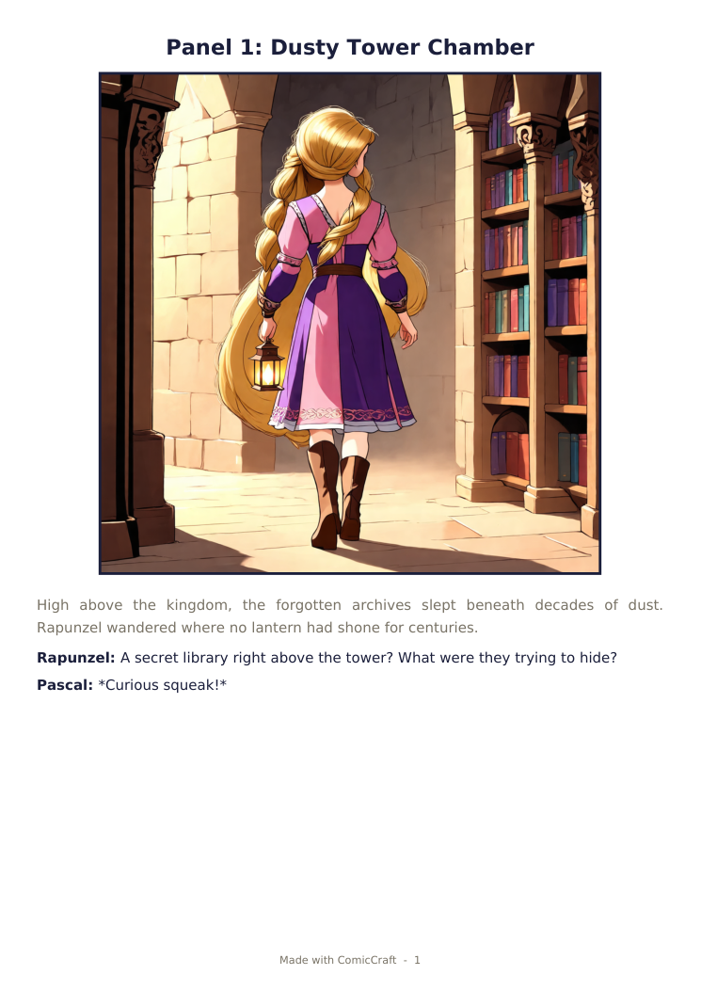

2. Generate Structured Comic Panel Outline - gemini_flash.py
Uses Gemini Flash to generate a 5-panel structured outline.
import google.generativeai as genai
import json
def generate_outline(prompt, character, setting, tone, art_style):
model = genai.GenerativeModel("models/gemini-1.5-flash")
system_prompt = f"""
You are a comic writer. Create 5-panel outline for:
Story: {prompt}
Character: {character}, Setting: {setting}
Tone: {tone}, Art Style: {art_style}
Return JSON list with: panel_number, title,
scene_description, image_prompt
"""
response = model.generate_content(system_prompt)
outline = json.loads(response.text)
return outline
OUTPUT:
Example topic: Rapunzel discovers a hidden library in the tower and finds an ancient Whispering Tome that reveals a secret passage.

3. Generate Comic Story Narration - gemini_pro.py
Gemini Pro expands the outline into a full story with captions and dialogues.
def generate_story(outline, character, tone):
model = genai.GenerativeModel("models/gemini-1.5-pro")
story_text = ""
for panel in outline:
prompt = f"""
Panel {panel['panel_number']}: {panel['title']}
Scene: {panel['scene_description']}
Character: {character}, Tone: {tone}
Write engaging narration + dialogues.
"""
res = model.generate_content(prompt)
story_text += res.text + "\n"
return story_text
OUTPUT:
Rapunzel: A secret library right above the tower? What were they trying to hide?
Rapunzel: It's humming... like it's been waiting for someone to find it.
The Tome: Rapunzel... unlock the light...
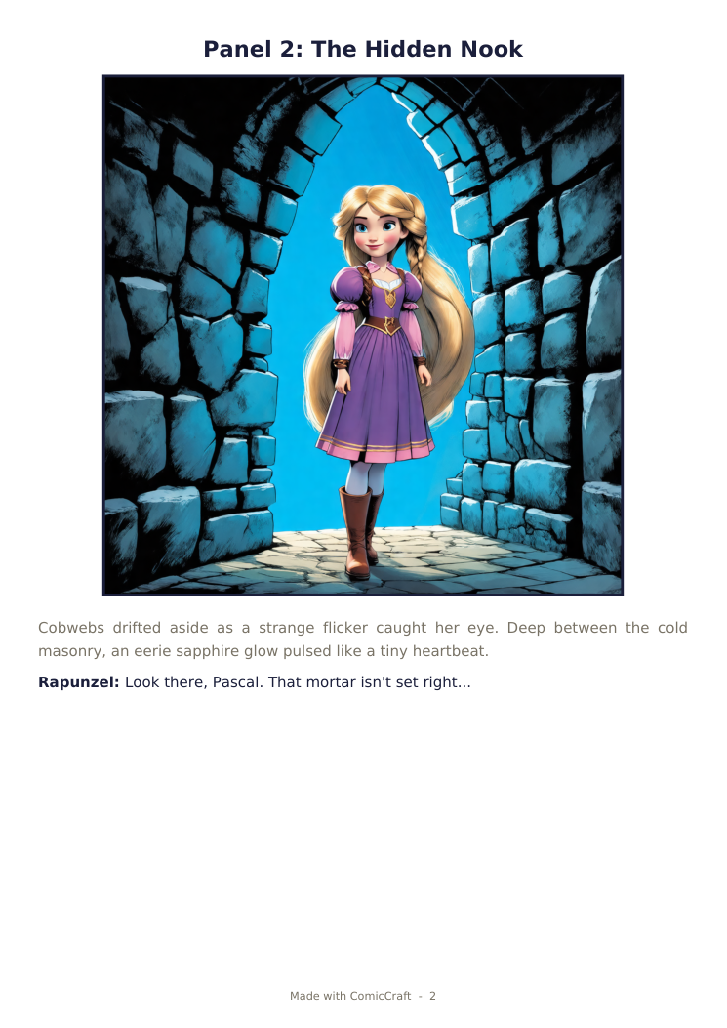

4. Generate Comic Illustrations - image_generator.py
Stable Diffusion generates comic-style images from prompts.
from diffusers import StableDiffusionPipeline
import torch
pipe = StableDiffusionPipeline.from_pretrained(
"runwayml/stable-diffusion-v1-5"
).to("cpu")
def generate_image(image_prompt, panel_number):
safe_prompt = f"comic book style, vibrant colors, {image_prompt}"
image = pipe(safe_prompt, num_inference_steps=30).images[0]
filename = f"panel_{panel_number}_{image_prompt[:20].replace(' ','_')}.png"
path = f"static/panels/{filename}"
image.save(path)
return path
OUTPUT:
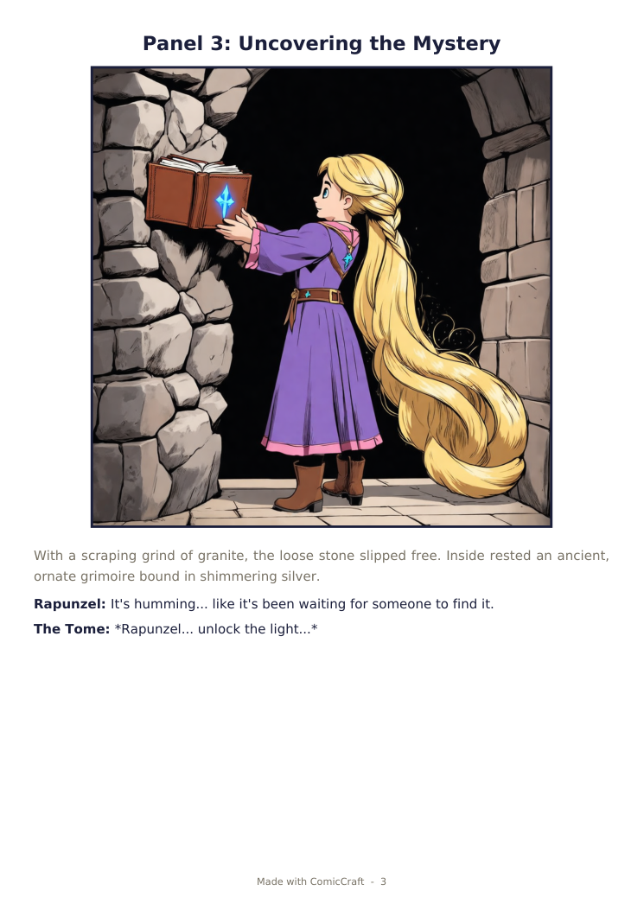
Sample visual topic: Rapunzel opens the ancient silver-bound tome and glowing starlight fills the hidden tower chamber.

5. Organize Layout & Export PDF - layout_builder.py & exporters.py
Builds the final panel layout and exports the comic as a PDF using FPDF.
def build_comic_layout(outline, images, story):
layout = []
panels_story = story.split("\n")
for i, panel in enumerate(outline):
layout.append({
'number': panel['panel_number'],
'title': panel['title'],
'image': images[i],
'scene': panel['scene_description'],
'text': panels_story[i] if i < len(panels_story) else "",
'image_prompt': panel['image_prompt']
})
return layout
from fpdf import FPDF
def save_pdf(layout, filename="comic.pdf"):
pdf = FPDF()
for panel in layout:
pdf.add_page()
pdf.set_font("Arial", 'B', 16)
pdf.cell(0, 10, f"Panel {panel['number']}: {panel['title']}", ln=True)
pdf.image(panel['image'], x=10, y=30, w=180)
pdf.set_xy(10, 150)
pdf.multi_cell(0, 8, panel['text'])
pdf.output(f"static/exports/{filename}")
return f"static/exports/{filename}"
OUTPUT:
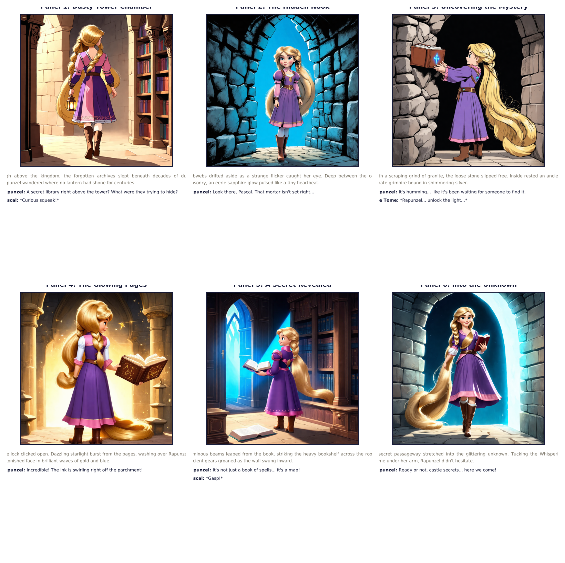
Generated comic topic: Rapunzel and the Whispering Tome.

6. FastAPI Routing - routes.py
Handles form submission, calls all AI workflows and renders comic_preview.html.
from fastapi import APIRouter, Form, Request
from fastapi.templating import Jinja2Templates
router = APIRouter()
templates = Jinja2Templates(directory="templates")
@router.post("/generate")
async def generate_comic(request: Request,
prompt: str = Form(...),
character: str = Form(...),
setting: str = Form(...),
tone: str = Form(...),
art_style: str = Form(...)):
outline = generate_outline(prompt, character, setting, tone, art_style)
story = generate_story(outline, character, tone)
images = [generate_image(p["image_prompt"], p["panel_number"])
for p in outline]
layout = build_comic_layout(outline, images, story)
pdf_path = save_pdf(layout)
return templates.TemplateResponse(
"comic_preview.html",
{"request": request, "layout": layout, "pdf_path": pdf_path}
)
OUTPUT:
The preview contains the six generated Rapunzel panels followed by the PDF download action.

7. Frontend UI Flow - Final Outputs
Homepage collects Story Prompt, Character, Setting, Tone, Art Style. Preview shows panel-wise comic with images, scene description, captions and narration. Export Success confirms PDF download.
Sample input for the changed comic topic:
Story Prompt: Rapunzel discovers a hidden library and a whispering magical tome.
Main Character: Rapunzel
Setting: Ancient tower / hidden library
Story Tone: Mysterious
Art Style: Comic Book
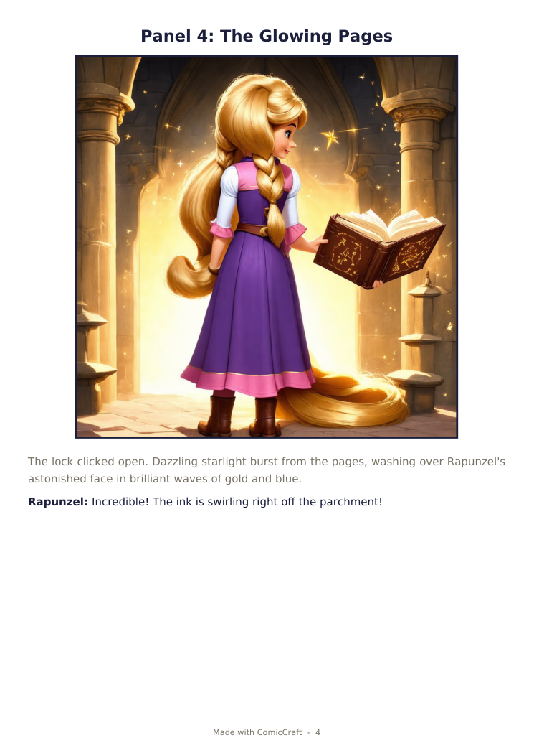
Final output topic: Rapunzel and the Whispering Tome.

Conclusion
ComicCraft successfully demonstrates AI-driven comic generation. Combining Gemini Flash for outline, Gemini Pro for narration, and Stable Diffusion for illustrations, it transforms a simple story prompt into a complete visually engaging comic.
For this documentation, the comic topic has been changed to "Rapunzel and the Whispering Tome" while retaining the same ComicCraft coding workflow.
Workflow: User Input -> Outline (Flash) -> Story (Pro) -> Images (SD) -> Layout Builder -> PDF Export (FPDF) -> Preview -> Download.

